MARS – Media Against Racism in Sport
Media Work Exchanges

REPORT

Football against racism - how to communicate a good idea through an animation video

Luis PEREIRA – University of Minho
Estefanía JIMÉNEZ - University of Basque Country

This report presents the three main parts of the activity developed within the scope of the media work exchange promoted by the MARS programme. It took place in March and April 2012, but several other meetings were arranged between the organizers, and with some public institutions which would be interested in joining the project to help to spread the final message.
Initially, the idea was developed as an audiovisual product especially designed in order to promote a message against racism in sports from a positive point of view. But for different reasons we decided to highlight the creative process and emphasize the Media Literacy activity underlying the creation of that product. Both these pedagogical activities involved students of Communication from two universities.
It is necessary to underline that the context of MARS was essential to give credibility to the project, when introducing our proposal both to students as to public institutions.
This report is divided into three parts, corresponding to the three main focuses of this project: organizations, students and general audience. Initially, we restate the general idea and the goals we wanted to achieve from the beginning.

Summary of the main goals
The starting points of this activity were:
- To involve communication students in the process of creating audiovisual messages against racism;
- To produce a final multimedia product and evaluate its impact on people and on institution partners;
- To spread that message, which the students would be involved in creating, through a very popular and powerful event: a football match.
- To engage several institutions from different fields, such as research, local media and sports, and have them working together on the dissemination of that idea.

Our targets were the Communication students from the University of Basque Country (Spain) Country and the University of Minho (Portugal); the public institutions involved (see below); the supporters of the Athletic Club de Bilbao and of SC Braga; and society in general, of both Spanish and Portuguese regions, as our aim was to reach them through media coverage of the events.
Initially the project was based on the production and sharing of a short animation video to be shown during a match of two football teams from two different European regions: Athletic Club de Bilbao and SC Braga.
The first screening is going to take place in September, even though at this moment the final video is not quite finished – because it has been waiting for further financial support from the Braga Youth European Capital, which is guaranteed to be contributed by the end of the year.
Football makes a great impact on these two regions and we have the support of the most popular teams. We are using their influence in order to promote intercultural awareness and concern against racism, particularly among Spanish and Portuguese youngsters. This process is, in our point of view, a innovative approach to Media Literacy and a powerful way to promote it.

Part I – Involving Organizations
As mentioned above, we have involved several institutions from the two regions. Those organizations have different missions, but they have in common a responsibility to Youth. It was clear to us that it was essential to make them aware of the importance of promoting Media Literacy among young people, a concept that they were not familiar with.
The institutions we have involved are the following:

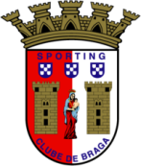 | Sporting Club de Braga | www.scbraga.pt
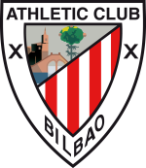 | Athletic Club | www.athletic-club.net
 | Braga 2012: European Youth Capital - Braga | www.bragacej2012.com
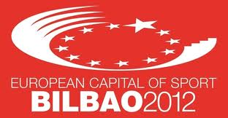 | Bilbao - European City of Sport 2012

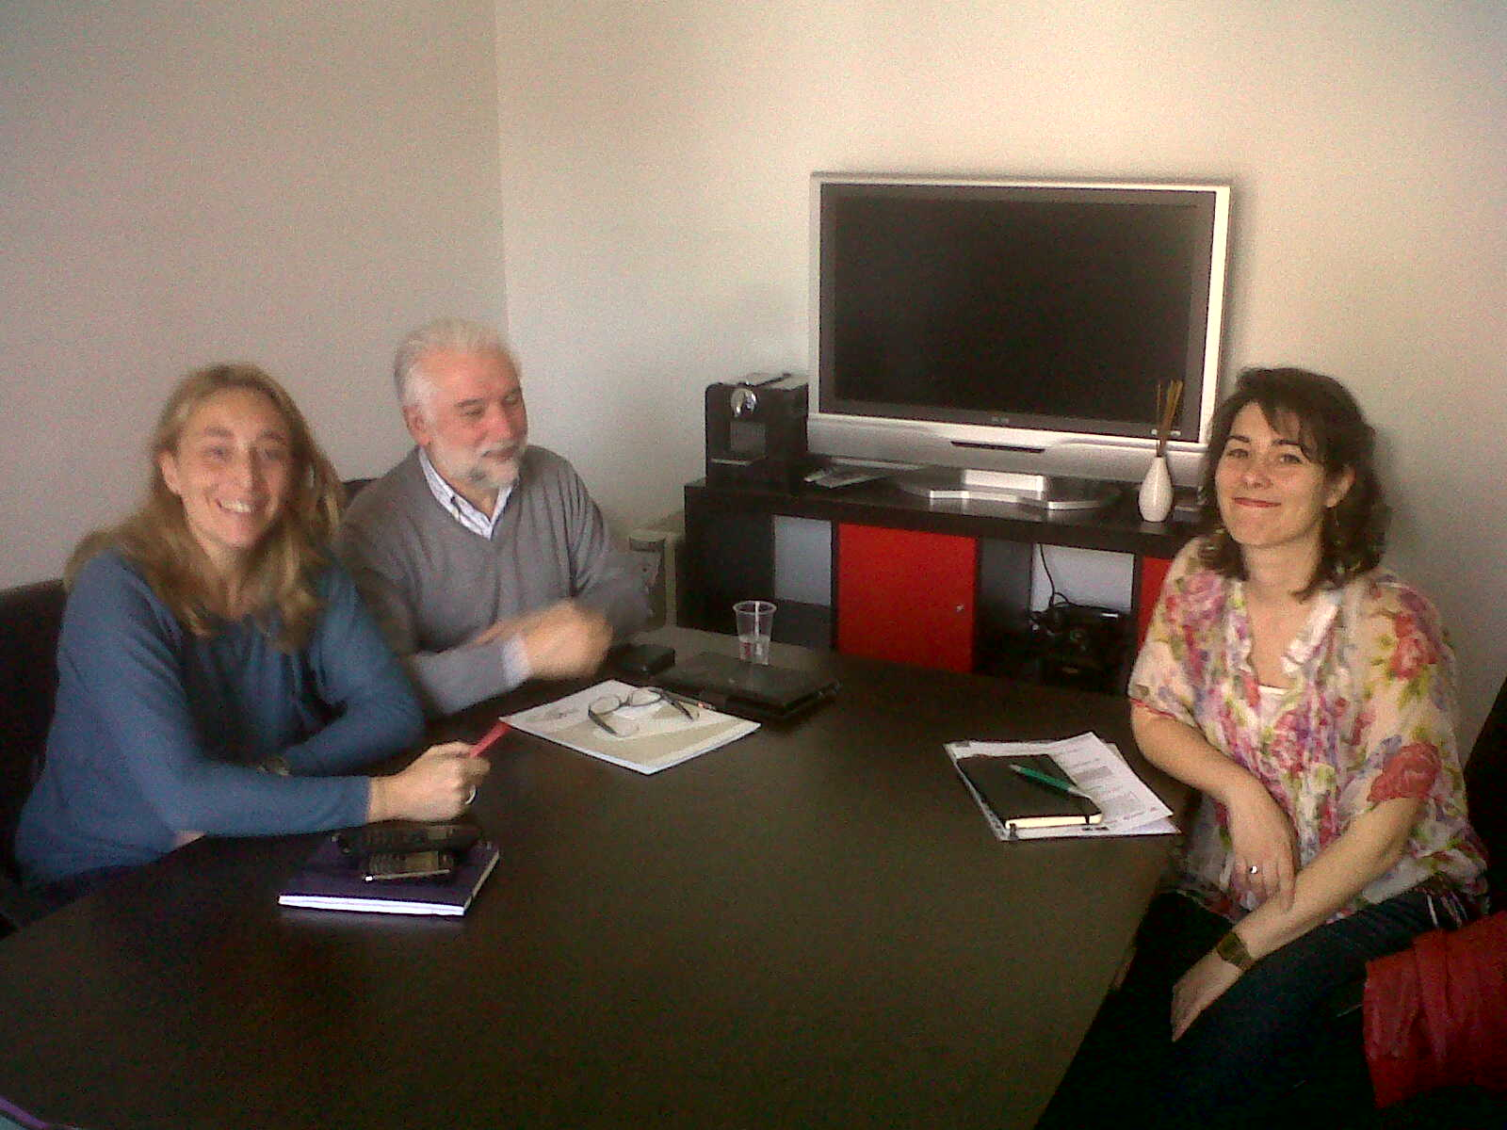
Meeting with some members of Bilbao European City of Sports 2012 – Bilbao, March – 2012

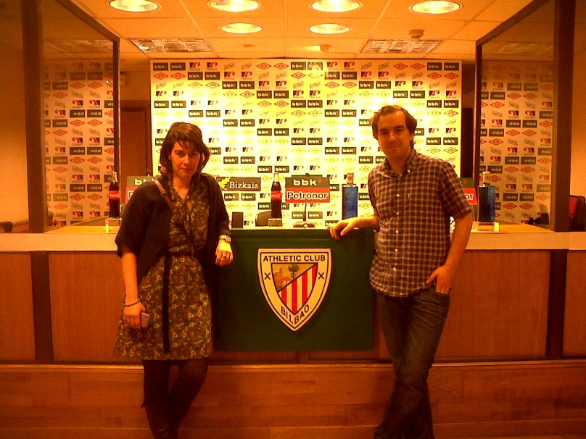
Visiting the press room of Athletic Stadium – Bilbao, March – 2012

Initially, we presented our idea and the goals of MARS to these institutions, asking for their support in putting the idea into action. The clubs agreed to show the video during a match, the Braga Youth Capital offered to support the costs of the video (about 3.000 Euros), and both universities gave institutional support and allowed the activity with students. Besides, the members of Bilbao European City of Sport 2012 wanted to use the video in other sports events and even proposed to share it through SNS in order to reach a wider audience.
The institutions were very receptive to the idea, as they found it interesting. Making them familiar with the idea of Media Literacy and with the importance of involving young people in the creation of the final product were our main achievements. It proves that we should work with these kinds of institutions in order to increase the impact of the initiative. The exchange support offered by MARS and the context it gave were essential for that.

Part II: Involving Students
A main goal was to involve students. We developed an activity with undergraduates of Communication Studies in universities, in both Portugal and Spain.
At the University of Minho, we invited Pedro Mota Teixeira, the person who is making the video, to talk about different techniques of animation: how they can work, what is beyond animation and how we can design an animation video taking into account our goals and targets.
It was very interesting for students because it showed them, for instance, how some of the best know animation videos were made. It also gave them more “tools” for thinking about ideas for the video.
Before the brainstorming, there was a foundation teacher – Luísa Sobral - who talked about her experience of teaching children about animation cinema and cartoons. She explained the activity she developed with them and how they became more critical viewers and more aware of the different techniques of animation.
Then, the students split into groups and were asked to develop a storyline for the video we had to make, not only in terms of ideas, but also in terms of the kind of techniques they would use.
In Spain, a similar activity was developed, but more focused on the brainstorming. The students took advantage of a talk on animation techniques and their possibilities in order to create an audiovisual output, which was given by Iñigo Maestro, a professional from the animation audiovisual industry.
As result, we received 12 storylines from the 12 groups of students, all of them displaying very meaningful ideas. The final video, which will be shown in September, is really built on the ideas of these students.

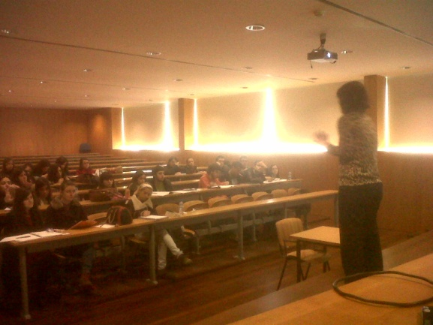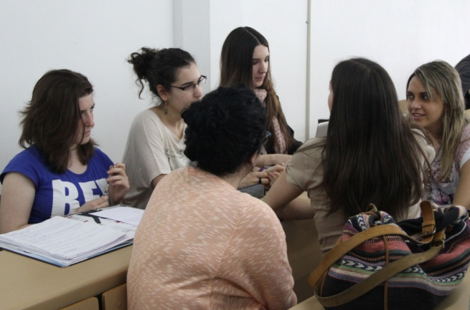
Work with students, at University of Minho and at University of Basque Country, 2012

Part III – Output
The final goal was to make an animation video based on the ideas of the Spanish and the Portuguese students.

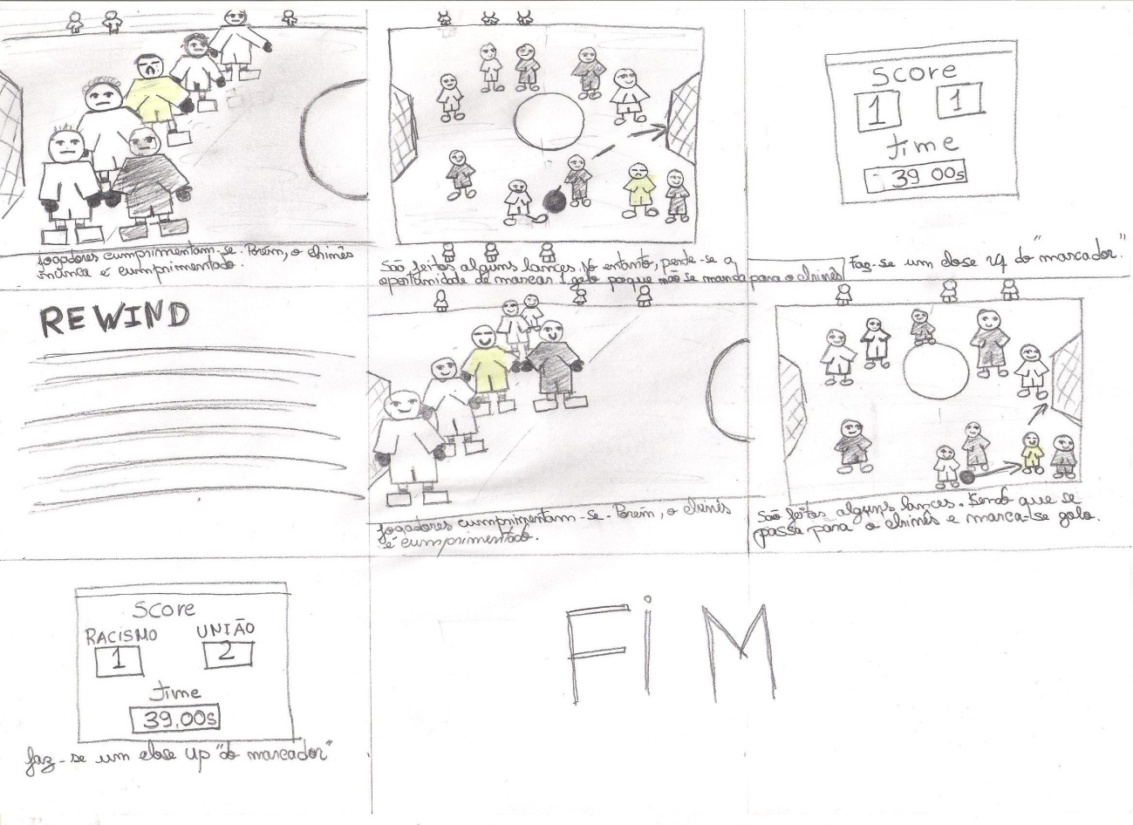
Example of a storyboard designed by a group of students from the University of Minho

The video was supposed to have been finished by now but, as explained, unexpected issues with the financial support delayed this task. However, the problems have been solved and work is ongoing. It will be finished soon and will be shown in stadiums in September at the beginning of next football season.
We can already give details of the main characteristics of this video. It will last between 30 seconds and 1 minute; it will be shown either at half time or at the beginning of a football match. The video shows people watching a televised football match at home, emphasizing the reality of the mediation of sport. The slogan which gives the main message is:
Teams have colours, players not.
Back your colours, respect people.

It appears in English, Portuguese, Spanish and Basque:
Portuguese: As equipas têm cores, os atletas não. Apoia as tuas cores, respeita as pessoas.
Español: Los equipos tienen colores, los deportistas no. Defiende tus colores, respeta a las personas.
Basque (euskera): Taldeek koloreak dituzte, kirolariek ez. Zeure koloreen alde jokatu, pertsona guztiak errespetatu.

Final comments
We consider this activity to be groundbreaking and successful, having positive feedback from all involved, both organizations and students. Our only regret is that the video is not yet complete but we are convinced the final result will worth all the effort and work that is going into it.
We have developed with students a replicatable, engaging Media Literacy activity for use in similar contexts. They have become more aware of the power of animation and, as Communication students, it was very important for them to recognize the possibilities that these kinds of projects and partnerships offer to develop young people’s awareness of media intervention.
Most recently, a paper submitted to an International Media literacy Conference in Lisbon next May has been accepted. It means the impact of the project will be disseminated to other academic institutions, it means the goals of MARS will continue even though this successful project is about to finished.

